**XML Conversion:**

In workflow nodes we have a node ‘Convert Data’ which is actually used to convert data from one format to another format.There are few formats which are being supported like json ,json objects,xml,yaml conversions etc.

As of now we already have support to convert data to xml format. To this one more field is added which is the ‘Root Element Name’. So when we are trying to convert data to xml format a parent element can be added if required.

**Screenshots:**

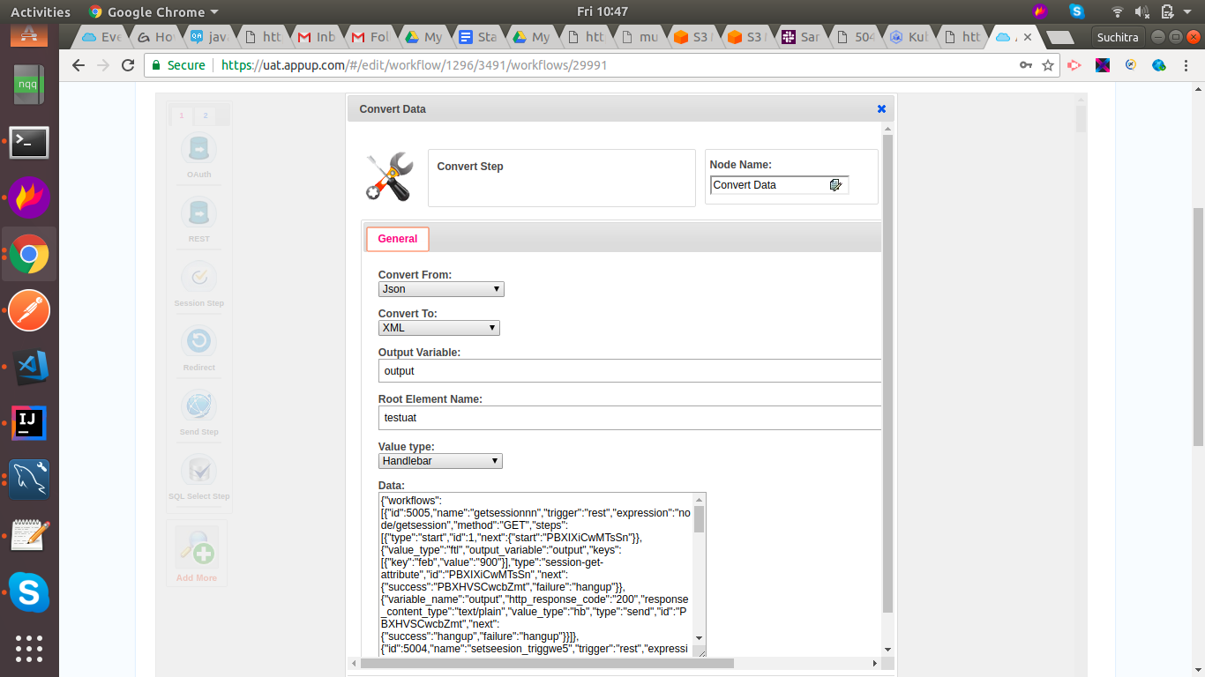

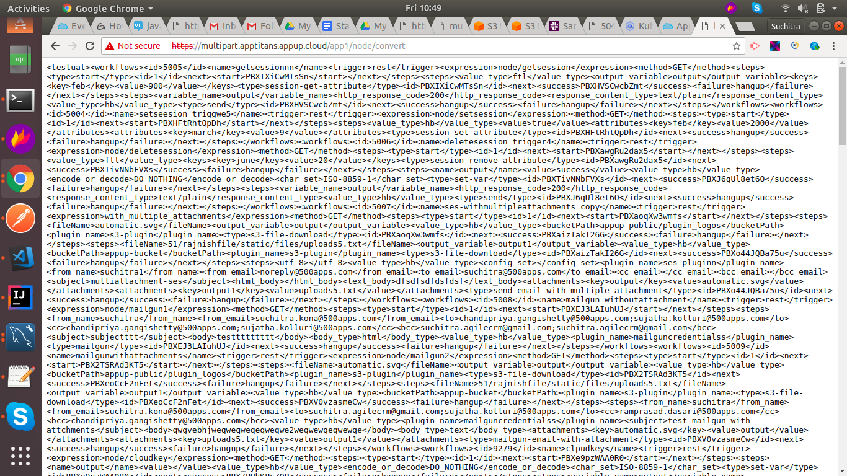

**Postman Link:**

<https://www.getpostman.com/collections/92d4326337612d58dbdd>